Linux Commands End to End Cheat Sheet
Command: whoami

      - Description: Displays the current user account.
      - Example: Running whoami in the terminal will show your username, like john_doe.

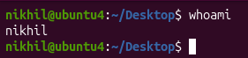

Command: ls
      - Description: Lists files and directories in the current directory.
      - Example: ls will display files and folders in your current directory, and ls -l provides detailed information.
      - 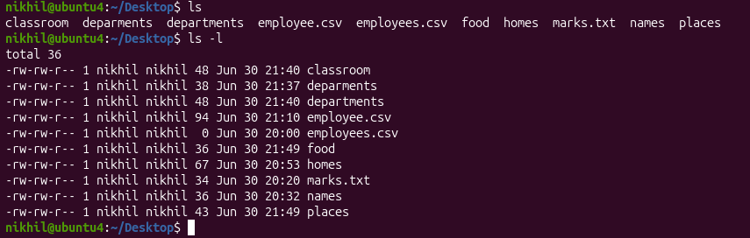

Command: ip a
      - Description: Lists your IP address and network interfaces.
      - Example: ip a show all network interfaces and their IP addresses.

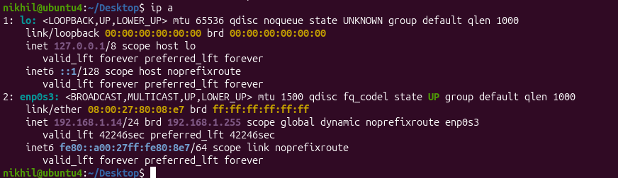
Command: cat
      - Description: Reads the contents of text files.
      - Example: cat myfile.txt will display the content of myfile.txt.
      - 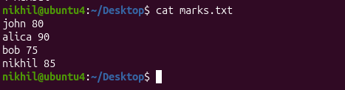
Command: passwd
      - Description: Used to change the password of the user account.
      - Example: Typing passwd and following the prompts will allow you to change your password.

Command: touch
      - Description: Creates empty files, mainly useful to test write ability.
      - Example: touch newfile.txt creates an empty file named newfile.txt.
Command: pwd
      - Description: Stands for Print Working Directory; shows which directory you are in.
      - Example: Running pwd might return /home/john_doe.
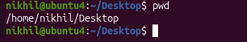
Command: man
      - Description: Accesses the system documentation for commands.
      - Example: man ls will show the manual for the ls command.
      - 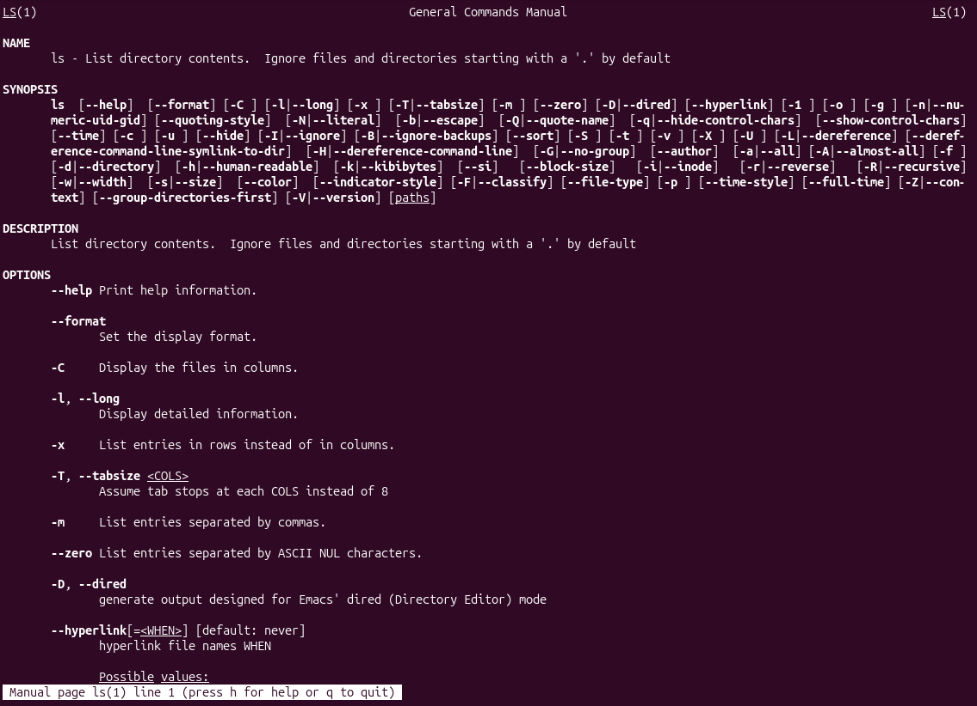
Command: apropos
      - Description: Searches commands related to a specific task based on description (equivalent to man -k).
      - Example: apropos "list files" might return commands related to listing files.
      - 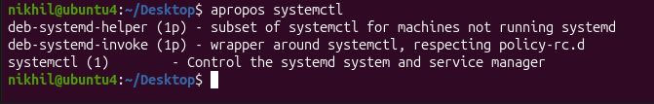
Command: pinfo
      - Description: Provides additional information, similar to man.
      - Example: pinfo ls gives detailed information about the ls command.
      - 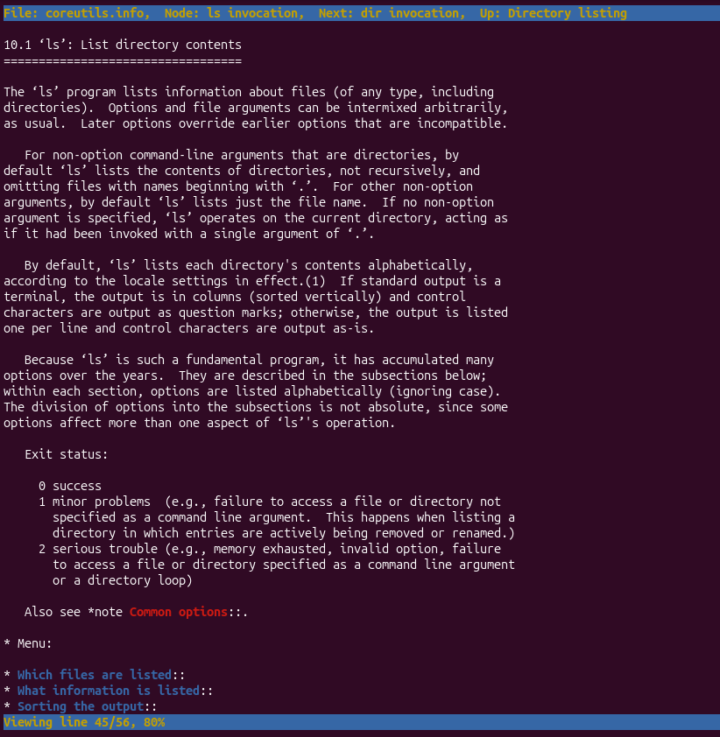
Command: tldr
      - Description: Shows command line examples, a simplified version of man.
      - Example: tldr passwd provides quick examples of how to use the passwd

Essential File Management Tools Commands

Command: ls
- Example: ls /home/user/Documents
- Description: Lists files and directories within a specified path. This command is used to view the contents of directories.
- 
Command: cp
- Example: cp source.txt destination.txt
- Description: Copies files from one location to another. This command is used to make duplicates of files.
- 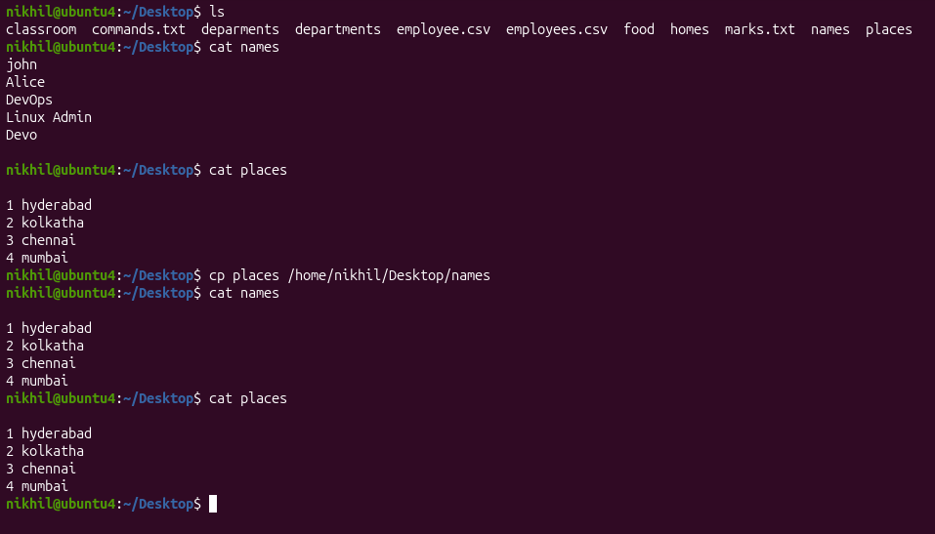
Command: mkdir
- Example: mkdir new_directory
- Description: Creates a new directory. This command is used when you need to make a new folder.
- 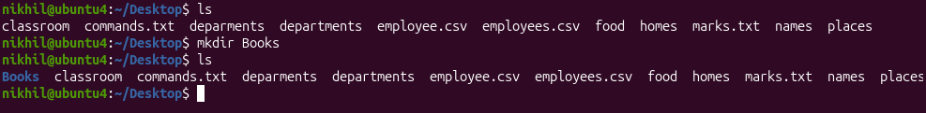
Command: rmdir
- Example: rmdir empty_directory
- Description: Removes a directory, but only if it's empty. This command is used for deleting empty folders.
- 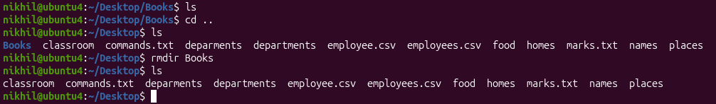

Command: mv
- Example: mv oldname.txt newname.txt
- Description: Moves or renames files and directories. This command can change the location or the name of a file.
- 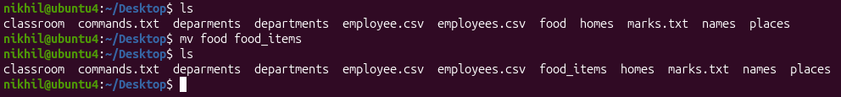
Command: rm
- Example: rm filename.txt
- Description: Removes files or directories. This command deletes files or directories.
- Note: When combined with options -r (recursive) and -f (force), as in rm -rf directory_name, it becomes a powerful command that can delete directories and their contents without asking for confirmation.
- 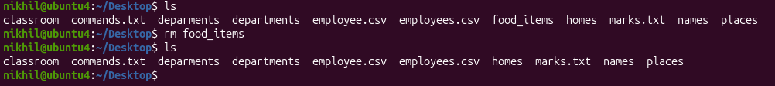

Advanced File Management Tools Commands

ln: Used for creating hard and symbolic links.
  - Example: ln -s source_file symbolic_linkcreates a symbolic link to source_file.
  - Description: Links a file or directory to another location.
  - 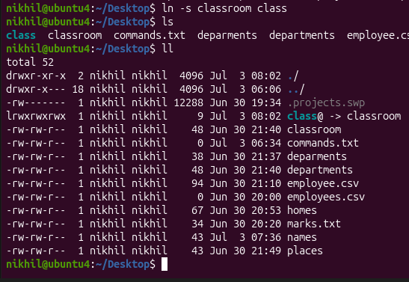
find: A utility to find files based on various properties.
  - Example: find /home -name "*.txt"searches for text files in the /home directory.
  - Description: Searches for files and directories in a given path.
  - 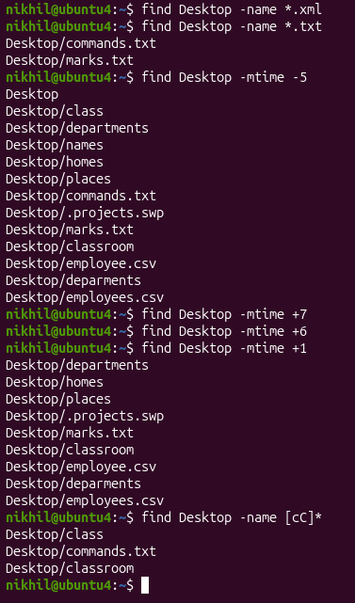
locate: Used for quickly searching the database of system's contents.
  - Example: locate filename finds the location of filename.
  - Description: Fast file searching, requires running updatedb for an updated database.
  - 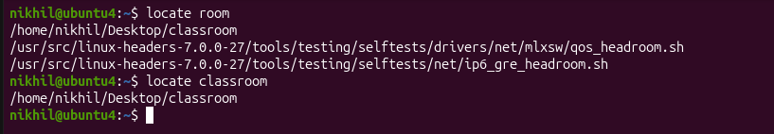
which: Finds the location of executables in the PATH.
  - Example: which python shows the path of the Python executable.
  - Description: Useful for finding executable files in system's PATH.
  - 
tar: Archives multiple files into a single file.
  - Example: tar -cvf archive.tar /foldercreates an archive of a folder.
  - Description: Combines multiple files into a tarball.
  - 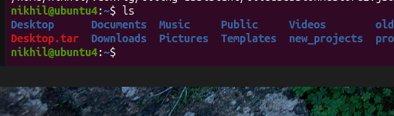
gzip: Compresses files.
  - Example: gzip file.txt compresses file.txt.
  - Description: Reduces the size of files using compression.
bzip2: A file compression utility.
  - Example: bzip2 file.txt compresses file.txt.
  - Description: Offers better compression ratios than gzip at the cost of speed.
  - 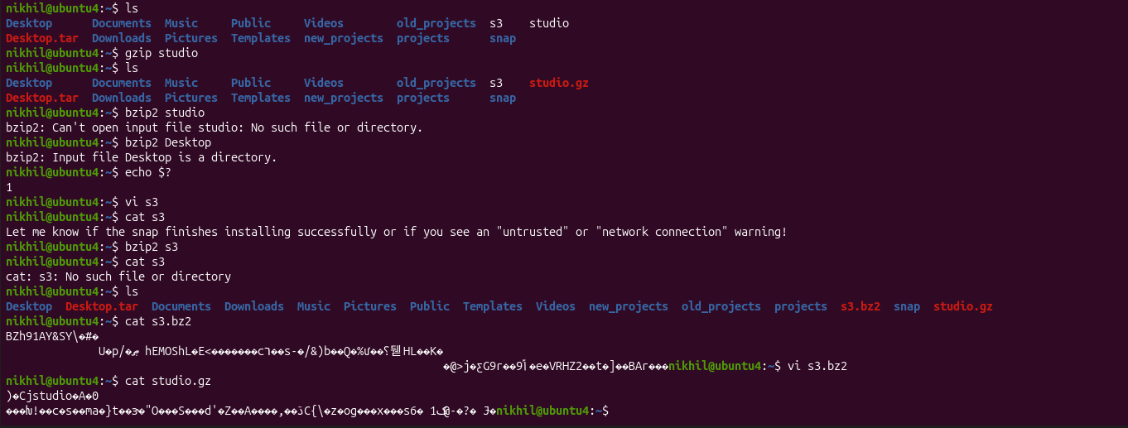

xz: High compression utility.
  - Example: xz file.txt compresses file.txt.
  - Description: Provides the best compression ratio.
  - 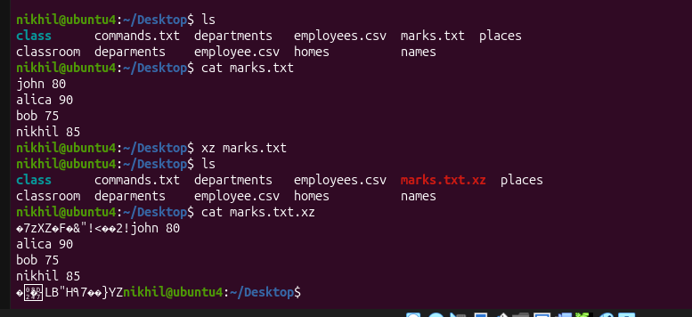
zip: Used for packaging and compressing (archiving) files.
  - Example: zip archive.zip file1 file2 creates an archive with file1 and file2.
  - Description: Commonly used for creating .zip files.
  - 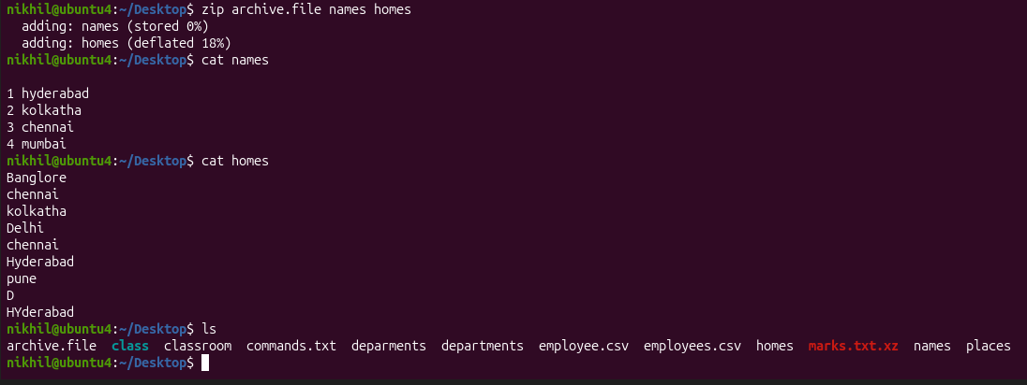

file: Determines the type of a file.
  - Example: file image.jpg displays the type of image.jpg.
  - Description: Useful for identifying file formats.
  - 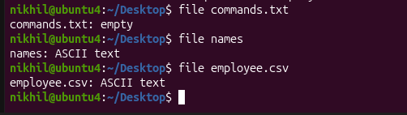
mount: Attaches a filesystem to a specified directory.
  - Example: mount /dev/sdb1 /mnt mounts the device sdb1 to /mnt.
  - Description: Used to access filesystems on different storage devices.
df: Displays disk space usage of all mounted filesystems.
  - Example: df -h shows disk space in human-readable format.
  - Description: Useful for monitoring disk space usage.
  - 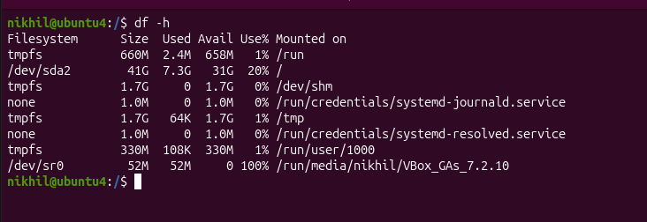

  - 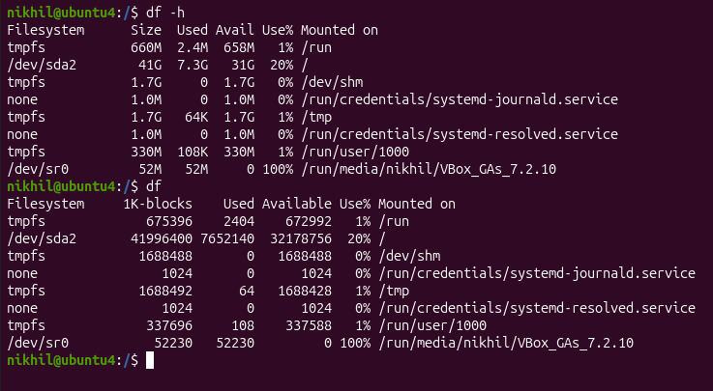
findmnt: Lists all mounted filesystems.
  - Example: findmnt -t ext4 lists all ext4 type mounts.
  - Description: Displays a tree-like structure of mounts.
  - 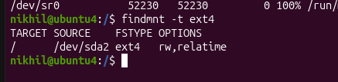
lsblk: Lists information about block devices.
  - Example: lsblk lists all block devices.
  - Description: Useful for identifying storage devices and their partitions. 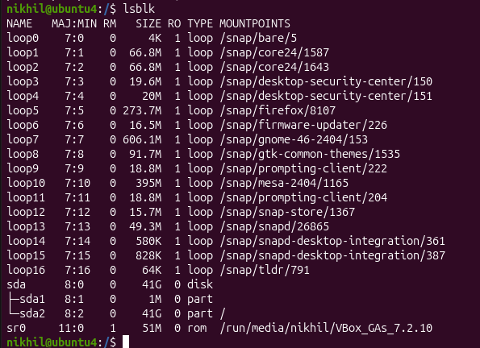

Working with Text Files Commands

nano
  - Description: A user-friendly text editor.
  - Example: nano filename.txt - Opens filename.txt in nano editor.
vimtutor
  - Description: A tutorial program for learning VIM, an advanced text editor.
  - Example: vimtutor - Starts the VIM tutorial.
vi
  - Description: The original text editor, with basic features.
  - Example: vi filename.txt - Opens filename.txt in VI editor.
  - 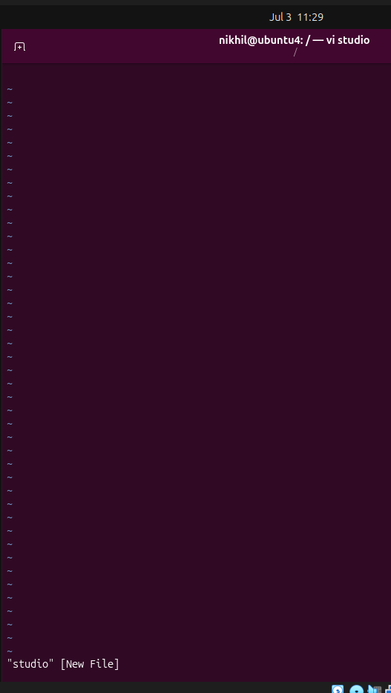
vim
  - Description: An improved version of VI with more features.
  - Example: vim filename.txt - Opens filename.txt in VIM editor.
more
  - Description: A pager to view the contents of text files, one screen at a time.
  - Example: more filename.txt - Views the content of filename.txt.
  - 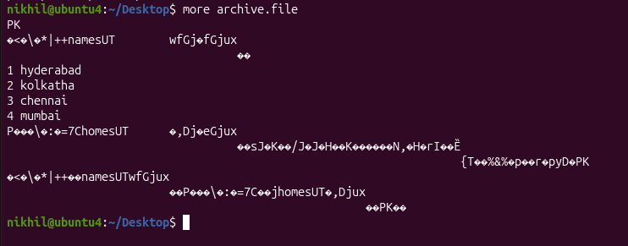
less
  - Description: Similar to more, but provides more control over viewing text files.
  - Example: less filename.txt - Opens filename.txt for viewing with navigation options.

head
  - Description: Displays the first few lines of a text file.
  - Example: head filename.txt - Shows the top lines of filename.txt.
  - 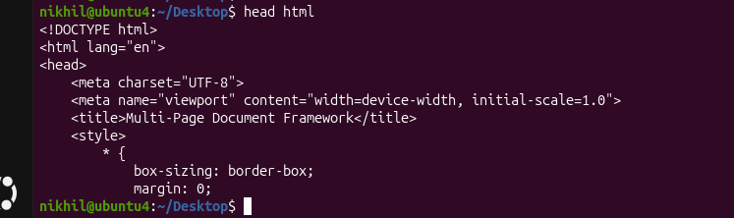
tail
  - Description: Displays the last few lines of a text file.
  - Example: tail filename.txt - Shows the last lines of filename.txt.
  - 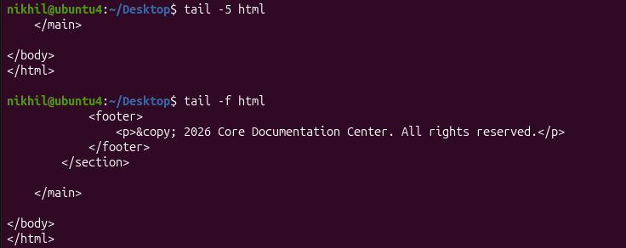
cat
  - Description: Concatenates and displays the entire content of text files.
  - Example: cat filename.txt - Displays the full content of filename.txt.
  - 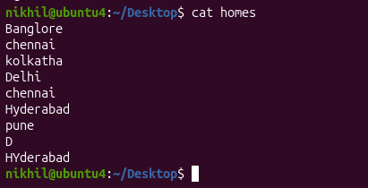
cat -A
  - Description: Similar to cat, but also displays special characters.
  - Example: cat -A filename.txt - Shows the content of filename.txt, including special characters.
  - 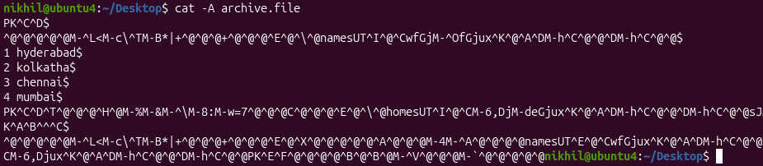
tac
  - Description: Prints the contents of a text file in reverse order.
  - Example: tac filename.txt - Displays filename.txt content backwards.
  - 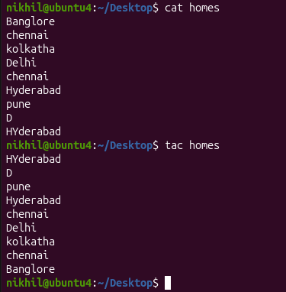
grep
  - Description: Searches for text in files or command output.
  - Example: grep 'pattern' filename.txt- Searches for 'pattern' in filename.txt.

Advanced Text File Processing Commands

grep:
  - Command: "grep"
  - Example: "grep 'pattern' file.txt"
  - Description: Filters text in files by searching for specific patterns.
  - 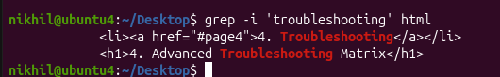
awk:
  - Command: "awk"
  - Example: "awk '/pattern/ {print}' file.txt"
  - Description: Filters and processes text, with additional features for text manipulation.
  - 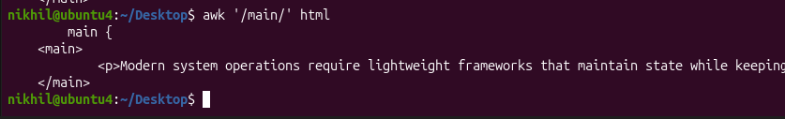
sed:
  - Command: "sed"
  - Example: "sed 's/old/new/' file.txt"
  - Description: A stream editor used for modifying text files directly from the command line.
  - 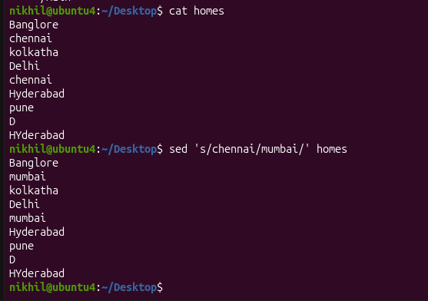
tr:
  - Command: "tr"
  - Example: "tr '[:lower:]' '[:upper:]' < file.txt"
  - Description: Translates or deletes characters from input text.
  - 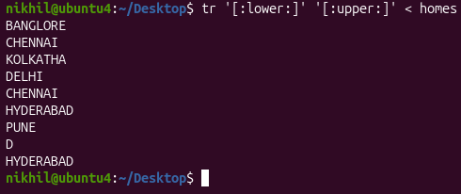
cut:
  - Command: "cut"
  - Example: "cut -d':' -f1 file.txt"
  - Description: Extracts sections from each line of files, such as columns from a table.
  - 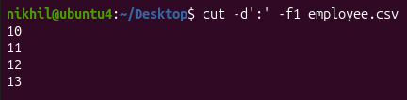
  - 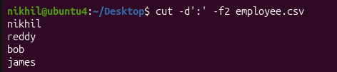
sort:
  - Command: "sort"
  - Example: "sort file.txt"
  - Description: Sorts text files in alphabetical or numerical order, as specified.
  - 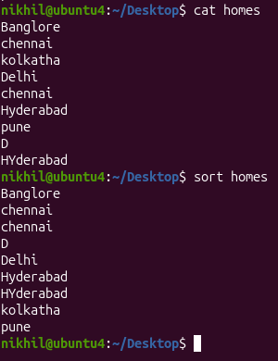

Connecting to a Server Commands
su Command
  - Example: su username
  - Description: This command is used to switch user identity in a Unix-like operating system. When you type su followed by a username, it prompts you for the password of that user and, if entered correctly, logs you in as that user.
  - 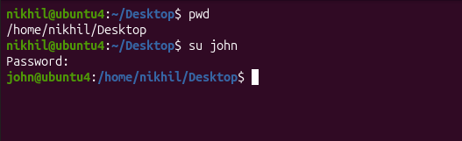
sudo Command
  - Example: sudo apt update
  - Description: The sudo command allows a permitted user to execute a command as the superuser or another user, as specified in the sudoers file. This example updates the list of available packages and their versions, but it requires administrative privileges, hence the use of sudo.
  - 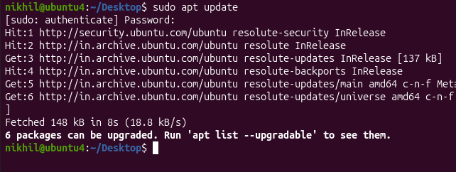

ssh Command
  - Example: ssh username@hostname
  - Description: ssh stands for Secure Shell. It's used to connect and log into a remote machine securely. The example shows how to connect to a remote host where username is your username on the remote machine, and hostname is the address of the remote machine.
scp Command
  - Example: scp file.txt username@hostname:/path/to/destination
  - Description: The scp command is used for secure copy from one machine to another. In the example, file.txt is being copied to a remote host. The username@hostname specifies the user and host of the remote machine, and /path/to/destinationis where the file will be placed on the remote machine.

Working with the Bash Shell commands

tee
  - Example: ls | tee file.txt
  - Description: Used in pipes to direct the output of a command both to a file and the next command in the pipe.
history
  - Example: history
  - Description: Displays a list of previously executed commands.
history -d
  - Example: history -d 1023
  - Description: Deletes a specific command from the history, where 1023 is the history entry number you want to remove.
alias
  - Example: alias ll='ls -l'
  - Description: Creates a shortcut for a longer command. In this example, typing ll will execute ls -l.
export
  - Example: export VAR=value
  - Description: Sets an environment variable VAR to a value value and makes it available to subshells.

User and Group Management and Permissions Commands

useradd: Adds users.
  - Example: useradd johndoe
  - Description: Creates a new user account named 'johndoe'.
  - 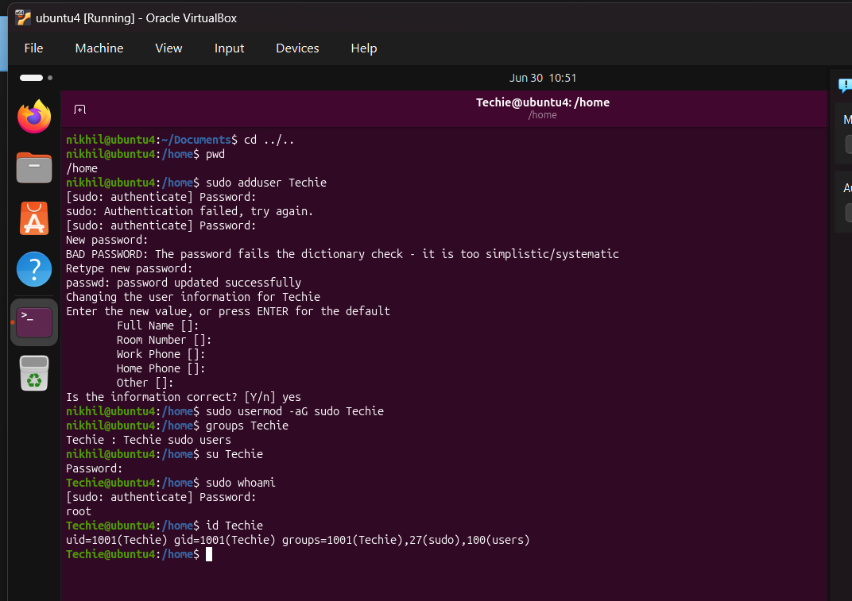
usermod: Modifies user properties.
  - Example: usermod -L johndoe
  - Description: Locks the user account 'johndoe'.
userdel: Deletes users.
  - Example: userdel johndoe
  - Description: Removes the user account 'johndoe'.
  - 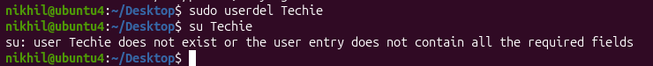
groupadd: Adds groups.
  - Example: groupadd developers
  - Description: Creates a new group named 'developers'.
  - 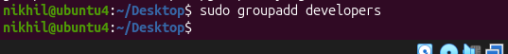
groupmod: Modifies group properties.
  - Example: groupmod -n newname oldname
  - Description: Renames a group from 'oldname' to 'newname'.
groupdel: Deletes groups.
  - Example: groupdel developers
  - Description: Removes the group named 'developers'.
id: Shows information about user accounts.
  - Example: id johndoe
  - Description: Displays user and group IDs for 'johndoe'.

getent: Gets information from administrative databases.
  - Example: getent passwd johndoe
  - Description: Retrieves user 'johndoe' details from the passwd database.
  - 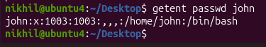
passwd: Changes passwords.
  - Example: passwd johndoe
  - Description: Sets or changes the password for 'johndoe'.
  - 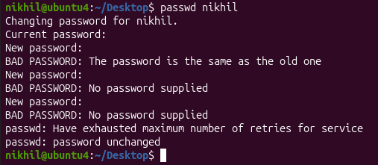
chage: Modifies password properties.
  - Example: chage -E 2023-12-31 johndoe
  - Description: Sets the expiry date of 'johndoe's password.
w: Shows logged-in users and details.
  - Example: w
  - Description: Lists users currently logged in with session details.
  - 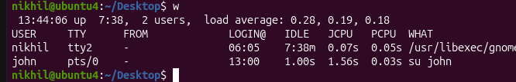
who: Shows currently logged-in users.
  - Example: who
  - Description: Lists users currently logged in with minimal details.
vipw: Edits the passwd file.
  - Example: vipw
  - Description: Opens the password file for editing.
  - 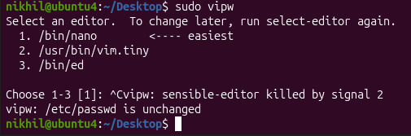
vigr: Edits the /etc/group file.
  - Example: vigr
  - Description: Opens the group file for editing.
  - 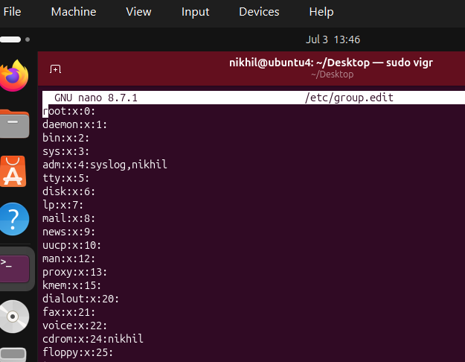
loginctl: Manages user sessions.
  - Example: loginctl list-sessions
  - Description: Lists current user sessions.
  - 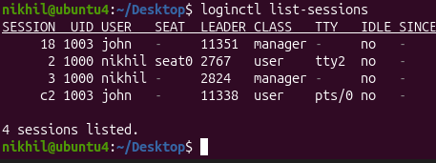

Permissions Management commands
chown
  - Example: chown user:group filename
  - Description: Changes the ownership of a file or directory. The command alters both user and group ownership. It's a versatile command that eliminates the need for chgrp in most cases.
chgrp
  - Example: chgrp group filename
  - Description: Changes the group ownership of a file or directory. While this command is dedicated to changing group ownership, chown can also perform this function.
chmod
  - Example: chmod 755 filename
  - Description: Changes the permission mode of a file or directory. It's an essential command for managing file and directory permissions in terms of read, write, and execute rights.
diff
  - Example: diff file1 file2
  - Description: Compares two files and displays the differences between them. This command is particularly useful in scenarios like checking changes in configuration files or script versions.
find (in the context of set user ID)
  - Example: find / -perm /4000
  - Description: Searches for files with set user ID permissions. This is important for security and system administration, to locate files that might have special privileges.
umask
  - Example: umask 022
  - Description: Sets the default permissions for newly created files and directories. It's a foundational command for establishing baseline security and access controls.

Storage Management Essentials commands
lsblk
  - Description: Lists all block devices.
  - Example: lsblk
  - This command displays information about all block devices connected to the system, such as hard drives and USB drives.
fdisk
  - Description: Manages partitions on an MBR disk.
  - Example: fdisk /dev/sda
  - Used for creating and managing disk partitions on an MBR (Master Boot Record) formatted disk.
gdisk
  - Description: Manages partitions on a GPT disk.
  - Example: gdisk /dev/sda
  - Similar to fdisk but for GPT (GUID Partition Table) formatted disks, which are more modern.
mkfs
  - Description: Creates a filesystem.
  - Example: mkfs.ext4 /dev/sda1
  - A generic utility to format a partition with a specific file system, such as ext4, xfs, or btrfs.

mount
  - Description: Attaches a filesystem to the file tree.
  - Example: mount /dev/sda1 /mnt
  - This command is used to mount a filesystem found on a device to a specific directory in the file tree.
findmnt
  - Description: Lists mounted filesystems.
  - Example: findmnt
  - Provides a detailed overview of all the filesystems currently mounted in the system.
umount
  - Description: Detaches the filesystem from the file tree.
  - Example: umount /mnt
  - Used to unmount a previously mounted filesystem.
lsof
  - Description: Lists open files and the processes using them.
  - Example: lsof /dev/sda1
  - Useful for diagnosing why a device might be busy, particularly if trying to unmount it and receiving a "device is busy" message.

Managing Networking commands

Command: ip a
  - Example: ip a
  - Description: Prints current IP address information, showing the IP addresses assigned to all network interfaces.
Command: ip route show
  - Example: ip route show
  - Description: Displays the routing table, including the default route, which is essential for understanding network routes.
Command: ping
  - Example: ping google.com
  - Description: Tests connectivity to a network host (e.g., a website like google.com) by sending ICMP packets.
Command: ss
  - Example: ss -tuln
  - Description: Shows socket statistics. Used to check open ports and listening services on the system.

Command: dig
  - Example: dig example.com
  - Description: Queries DNS information. It's useful for troubleshooting DNS issues or verifying DNS records.
Command: nmap
  - Example: nmap -v 192.168.1.1
  - Description: An advanced security analysis tool that scans networks and systems for open ports, services, and other security vulnerabilities.
Command: hostname
  - Example: hostname
  - Description: Displays the system's host name.
Command: hostnamectl
  - Example: hostnamectl set-hostname myhostname
  - Description: Used for host name management, including viewing and changing the system's hostname.

Working with Systemd commands
systemctl start
  - Example: systemctl start httpd
  - Description: Starts a specified unit file.
systemctl status
  - Example: systemctl status httpd
  - Description: Displays the current status of a unit file.
systemctl restart
  - Example: systemctl restart httpd
  - Description: Restarts a unit file, often used after making configuration changes.
systemctl stop
  - Example: systemctl stop httpd
  - Description: Stops a running unit file.
systemctl enable
  - Example: systemctl enable httpd
  - Description: Enables a unit file to start automatically on system boot.
systemctl disable
  - Example: systemctl disable httpd
  - Description: Disables a unit file from starting automatically on boot.
systemctl list-units
  - Example: systemctl list-units
  - Description: Lists all currently loaded unit files.

systemctl set-default
  - Example: systemctl set-default graphical.target
  - Description: Sets the default target that the system boots into.
systemctl get-default
  - Example: systemctl get-default
  - Description: Displays the current default target.
systemctl cat
  - Example: systemctl cat httpd
  - Description: Shows the configuration of a unit file.
systemctl show
  - Example: systemctl show httpd
  - Description: Displays all the options set for a unit file.
systemctl edit
  - Example: systemctl edit httpd
  - Description: Opens an editor to modify a unit file.
systemctl daemon-reload
  - Example: systemctl daemon-reload
  - Description: Instructs the systemctl main process to reload its configuration.
systemctl isolate
  - Example: systemctl isolate graphical.target
  - Description: Switches the system to a different target.
systemctl list-dependencies
  - Example: systemctl list-dependencies graphical.target
  - Description: Lists all dependencies of a specific target.

Managing Software Commands
Command: rpm
  - Description: Originally used for installing packages, rpm is now mainly used for querying information about installed packages.
  - Example: rpm -q package_name - This command queries details about a specific package.
Command: yum
  - Description: yum is a software package manager used in Red Hat-based environments for installing, updating, and managing packages.
  - Example: yum install package_name - This command installs a specific package.
Command: dnf
  - Description: Similar to yum, dnf is a modern package manager for Red Hat-based systems, offering improved performance and package management capabilities.
  - Example: dnf update - This command updates all installed packages to their latest versions.
Command: apt
  - Description: apt is a command-line tool used in Ubuntu and other Debian-based systems for handling packages, including installation, updating, and removal.
  - Example: apt install package_name - This command installs a specific package.
Command: apt-cache
  - Description: apt-cache is used for querying package information in Debian-based systems. It's especially useful for searching for packages containing specific files.
  - Example: apt-cache search keyword - This command searches for packages related to a specific keyword.

Managing SSH Commands

Change SSH Port on Ubuntu:
  - Command: sudo vim /etc/ssh/sshd_config
  - Description: Open the SSH configuration file using vim to change the SSH port.
Update SSH Port to 2022:
  - Command: Change the line Port 22 to Port 2022 in the file.
  - Description: In the SSH configuration file, update the default port from 22 to 2022.
Restart SSH Service:
  - Command: sudo systemctl restart sshd
  - Description: Restart the SSH daemon to apply the new configuration.
Allow Port 2022 in Firewall:
  - Command: sudo ufw allow 2022/tcp
  - Description: Update the Ubuntu firewall to allow TCP connections on port 2022.
Check SSH Service Status:
  - Command: sudo systemctl status sshd
  - Description: Verify that the SSH service is active and listening on port 2022.
Create SSH Session from Windows:
  - Description: Use MobaXterm on Windows to create a new SSH session.
  - Steps:
    - Open MobaXterm and select to create a new SSH session.
    - Enter the remote host IP address (e.g., 192.168.29.142).
    - Specify the username (student in this case).
    - Set the port to 2022.
    - Click OK to initiate the connection, then enter the password when prompted.

Managing Time commands
Command: date
  - Example: date
  - Description: Displays the current date and time of the system. It's a basic and long-standing command in many operating systems.
Command: hwclock
  - Example: hwclock --show
  - Description: Used for managing and viewing the hardware clock. It can also be used to synchronize the hardware clock with the system clock.
Command: timedatectl
  - Example: timedatectl status
  - Description: A modern utility for managing various aspects of time synchronization and settings. It can display and set time, date, and timezone, among other features.
Command: chronyc
  - Example: chronyc tracking
  - Description: Interfaces with the chronyd time-synchronizing service, providing detailed information about the current synchronization status and more control over the chronyd service.

Process Management Commands
Command: top
  - Example: top
  - Description: Monitors all processes and the general health of the system from a performance perspective.
Command: ps
  - Example: ps aux
  - Description: Shows all processes and their properties; useful for monitoring system processes.
Command: jobs
  - Example: jobs
  - Description: Lists the jobs (processes) started by the user in the shell, allowing for management of interactive processes.
Command: fg
  - Example: fg %1
  - Description: Brings a job to the foreground, where %1 is the job number.

Command: bg
  - Example: bg %1
  - Description: Sends a job to run in the background.
Command: nice
  - Example: nice -n 10 command
  - Description: Starts a process with a defined niceness (priority), where command is the command to be run with a priority.
Command: renice
  - Example: renice -n 10 -p 1234
  - Description: Changes the priority of an already running process, where 1234 is the Process ID (PID).
Command: kill
  - Example: kill 1234
  - Description: Sends a signal to a process (usually to terminate it), where 1234 is the Process ID (PID).
Command: killall
  - Example: killall processname
  - Description: Terminates all processes with the given name.

Scheduling Tasks Commands

at Command
  - Description: Allows you to schedule a job to run at a specific time.
  - Example: at 10:30 schedules a job to run at 10:30.
atq Command
  - Description: Displays a list of all jobs currently scheduled.
  - Example: atq shows all scheduled jobs with their job numbers.
atrm Command
  - Description: Used to remove scheduled jobs.
  - Example: atrm 5 removes the job with the job number 5.
Editing Cron Configuration with crontab -e
  - Description: Opens the cron configuration for editing, allowing you to schedule jobs to run periodically.
  - Example: crontab -e opens the cron configuration file in a text editor.
Working with Systemctl Timers Using systemctl
  - Description: Used to manage and interact with systemctl timers, a more systemwide approach for scheduling tasks.
  - Example: systemctl list-timers shows all active timers.

Reading Log Files Commands
Command: journalctl
  - Description: This command is used to check the contents of the systemd journal, which is a centralized logging system for Linux.
  - Example: journalctl -u nginx.service
    - This example shows how to view logs for the Nginx service using journalctl.
Command: tail
  - Description: The tail command is used to view the contents of log files, typically the last few lines.
  - Example: tail -n 100 /var/log/syslog
    - This example displays the last 100 lines of the syslog file.
Command: less
  - Description: Similar to tail, less is used for viewing log files but allows for more controlled navigation through the file.
  - Example: less /var/log/apache2/access.log
    - This opens the Apache access log file in a scrollable interface for in-depth examination.
Command: logger
  - Description: The logger command is a convenient tool for writing messages to the system log.
  - Example: logger "System backup completed"
    - This example sends a custom message, "System backup completed," to the system log.

